Website comments
H01
Project Development for a Sustainable Future
Add this under it: From an initial idea to feasibility, finance and implementation, Enerqa develops projects across climate action, energy transition, environment, nature, circularity, ESG and sustainable finance.
H03 – Global News
The news image background should not cover the entire section.
The selection of Background should be removed.
The Global News section should be larger and “wider”, more than “long” and fill all the page side margins, accounting for the side indentation. Better have a slide show of the news, at least 5 to cover all domains and main topics under them. Something like this (and look at how the high the image resolution is), with scroll arrows between news headlines.
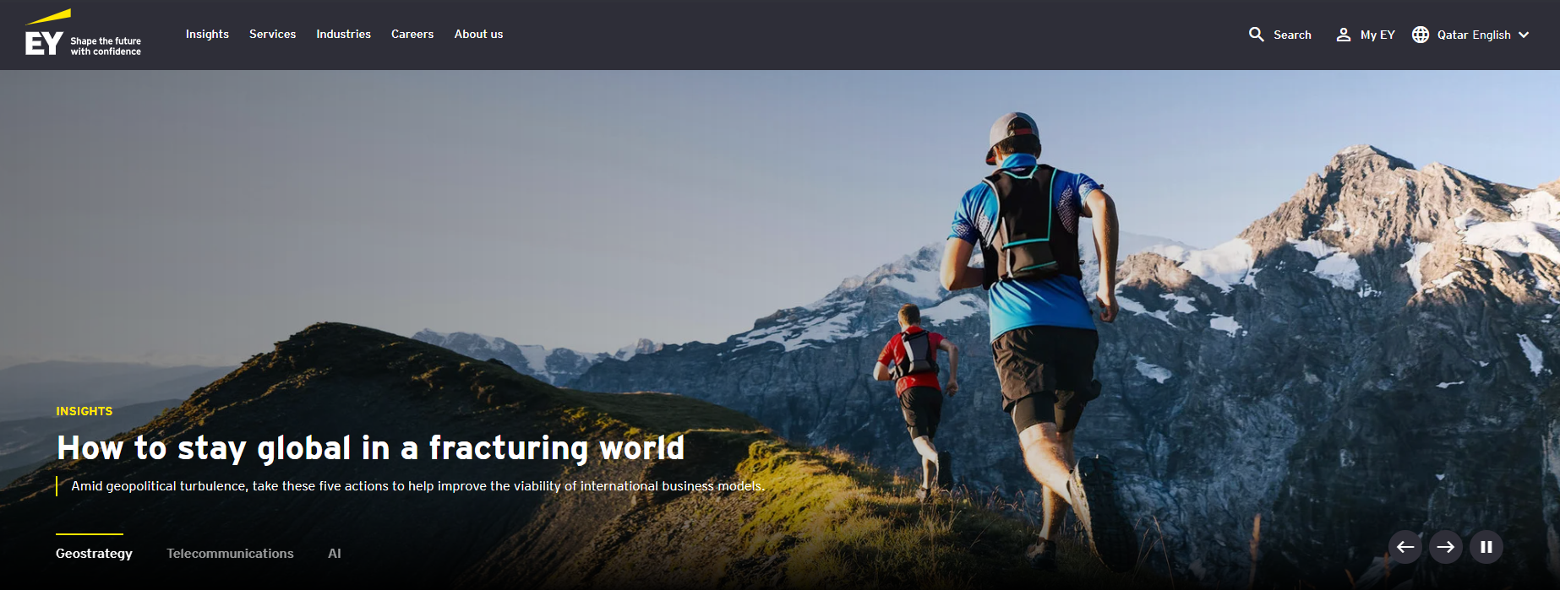
The resolution of the images is really bad, even though it is high resolution in the source. Is it from the API service? Or can it be fixed?
Also, I notice that NewsData.io has a day delay or more (it changes every 2 days or so when I check). Is there a better service (even if it’s a paid one; that can cost like 10 – 20 USD per month) that can be filtered for climate change / climate action, energy transition, nature, circularity and environment, and sustainable business, finance and ESG? Please check if EXA is legit and would you recommend it.
H04 – Major Markets
Major Markets part is a huge concern. So, propose paid APIs that can show live stock market updates of for example points up, down of different ticker symbols of companies, with commentary (with cost).
I think it would be better if the Global News and Major Markets are not side by side. Try making them equal height subsections within the first page fold.
Major Markets can be split into two columns (not necessarily of equal width; judgement based on how the API shows); one for ticker symbols points, graphs, etc and the other for commentary (depends on the proposed API).
The footnote under Global News and Major Markets: Is it legally necessary? Or can it be referenced in the sources page? Otherwise, make it smaller in font size with less details.
H05 – Explore Our Domains
Remove the background images.
No need for rotation; hence, remove pause rotation. It can be static, and respond only upon hovering over. The response meant is the appearance of the Discover command and the text snippet underneath the domain title.
H07 – Industries We Work In
Change the title into: Industries (remove “we work in”)
H11 – About Enerqa
Remove the gas manhole cover image. Its irrelevant. You may put the logo symbol (see if it’ll look nice; I think I sent it with the logo files).
The Domains and Industries Megamenu
It can definitely look better than this. I’ll leave that to you.
O01 – Domains and Industries
See if it would be better to centre the “Our Domains” title.
The icons of the domains do not look good, and they do not fit the feel of the website. We need another idea for this.
As earlier, change the title into: Industries (remove “we work in”)
We need to revise together the related data parts of all domains and industries (there’s a dependency on the API change proposed).
Knowledge Hub page
The articles are incomplete. All infographics are not there!
Remove the part “Executive Summary” from all articles.
Change Find a Publication into: “Search a topic”.
Filters: Remove Language, year, publication type, industry and topic filters. Leave only Domain filter.
Global Intelligence
Change the title Sources and Context into Sources. Remove “and Context”.
Make it small (fine print). Only include what is essential and necessary (rights of use).
Substitute “External Content Cards” with Results or anything appropriate.
This page needs a lot of work.

